Project Design Phase-II
Data Flow Diagram & User Stories

Date | 11 June 2026
Team ID
Project Name | Emotion Detection & Learning Support Engine
Maximum Marks | 4 Marks

Data Flow Diagrams:
A Data Flow Diagram (DFD) is a traditional visual representation of the information flows within a system. A neat and clear DFD can depict the right amount of the system requirement graphically. It shows how data enters and leaves the system, what changes the information, and where data is stored.
Example: DFD Level 0 (Industry Standard)
Example: (Simplified)
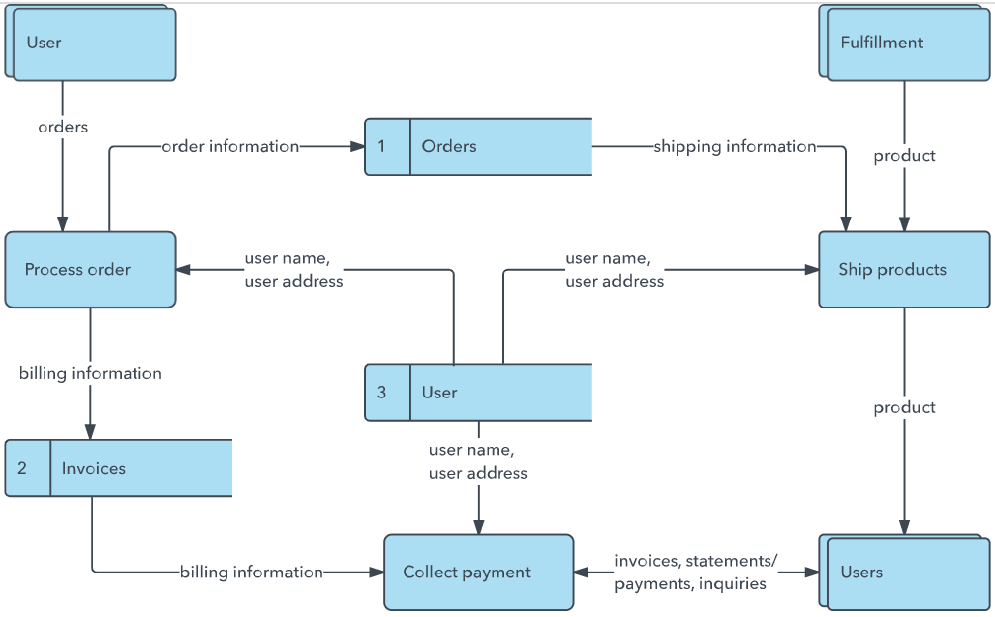


User Stories
Use the below template to list all the user stories for the product.
User Type | Functional Requirement (Epic) | User Story Number | User Story / Task | Acceptance criteria | Priority | Release
Learner (Self-Study) | Core Problem Diagnosis | USN-1 | As a learner, I can enter my study challenge in plain text so that I can get immediate emotional validation and study tips. | The system must ingest raw text input and return feedback tailored to the specific emotional state within seconds. | High | Sprint-1
Learner (Self-Study) | Progress Tracking | USN-2 | As a learner, I can review my mixed-emotion history so that I can self-reflect on my learning trends over time. | The app must read the saved session history and show historical tracking metrics. | Medium | Sprint-2
Academic Support (TA) | Message Triage Automation | USN-3 | As a TA, I can paste a student's message into the tool so that I can instantly detect if they are Confused or Frustrated. | The system must flag dominant emotional signals and display confidence distributions immediately. | High | Sprint-1
Academic Support (TA) | Automated Response Drafting | USN-4 | As a TA, I can toggle AI-generated guidance options so that I can quickly review a customized instructional reply. | The UI must provide a toggle switch to show Gemini-generated response cards with specific study steps. | High | Sprint-1
Administrator / Developer | Model Audit & Metrics | USN-5 | As a platform developer, I want to see a side-by-side comparison of the BiLSTM and BERT models to assess system performance. | The Streamlit web interface must feature an analytics dashboard showing contrasting prediction matrix parameters. | Medium | Sprint-2

